OS TUTORIAL 2

Name: Sayali Wagh Roll No.: 67 Div: D

1) Write a shell script to check number entered by the

user is greater than 10.

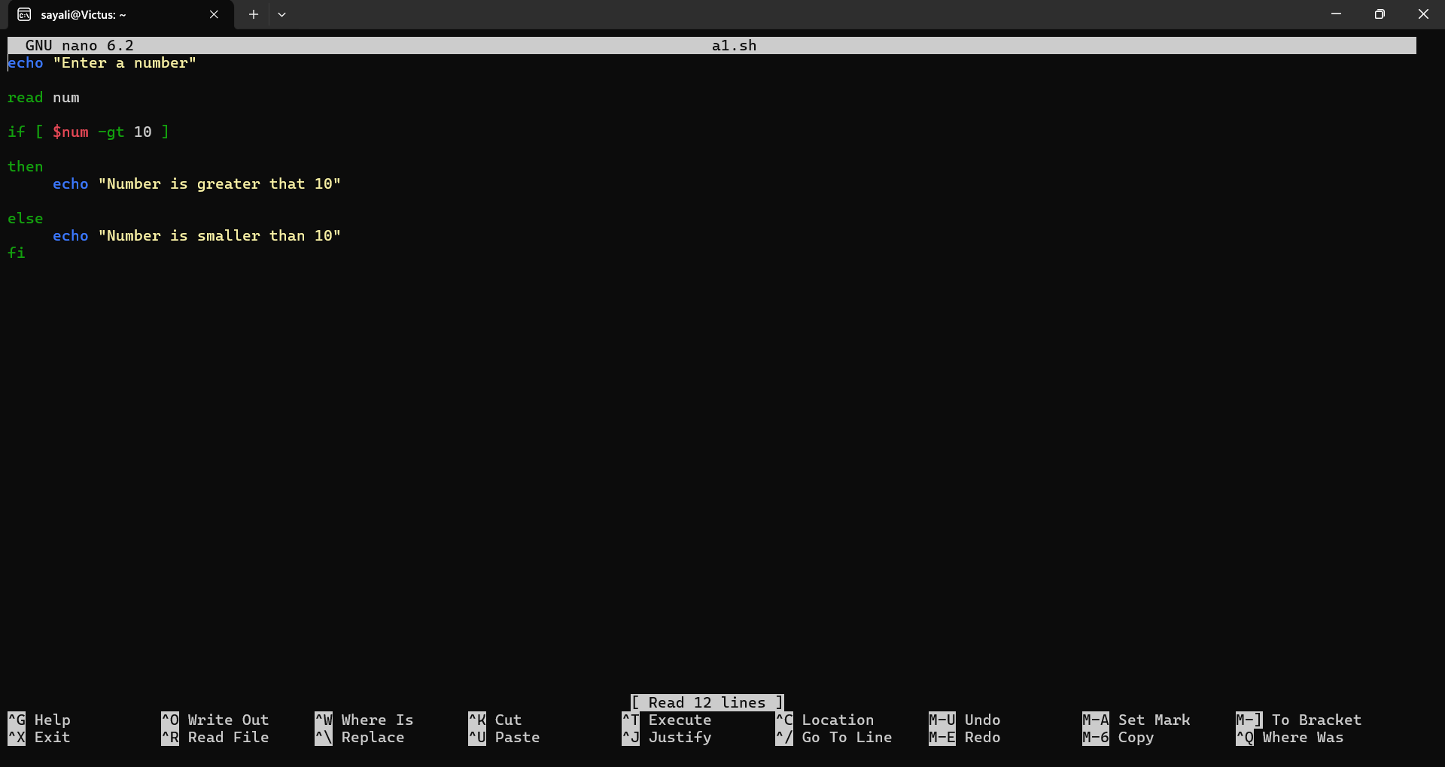

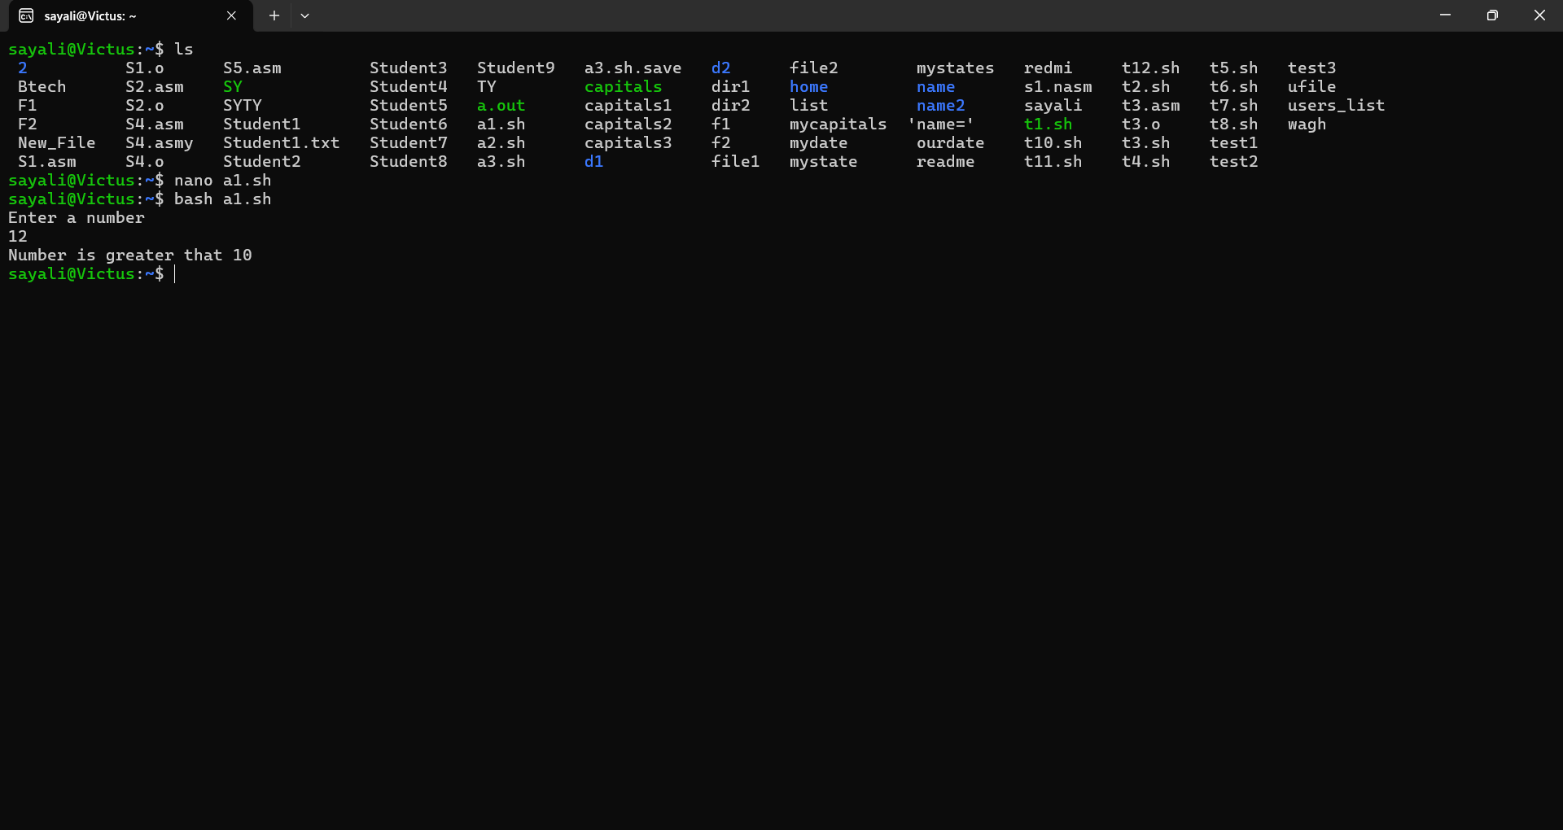

2) Write a shell script to check if a file exists. If not, then create it.

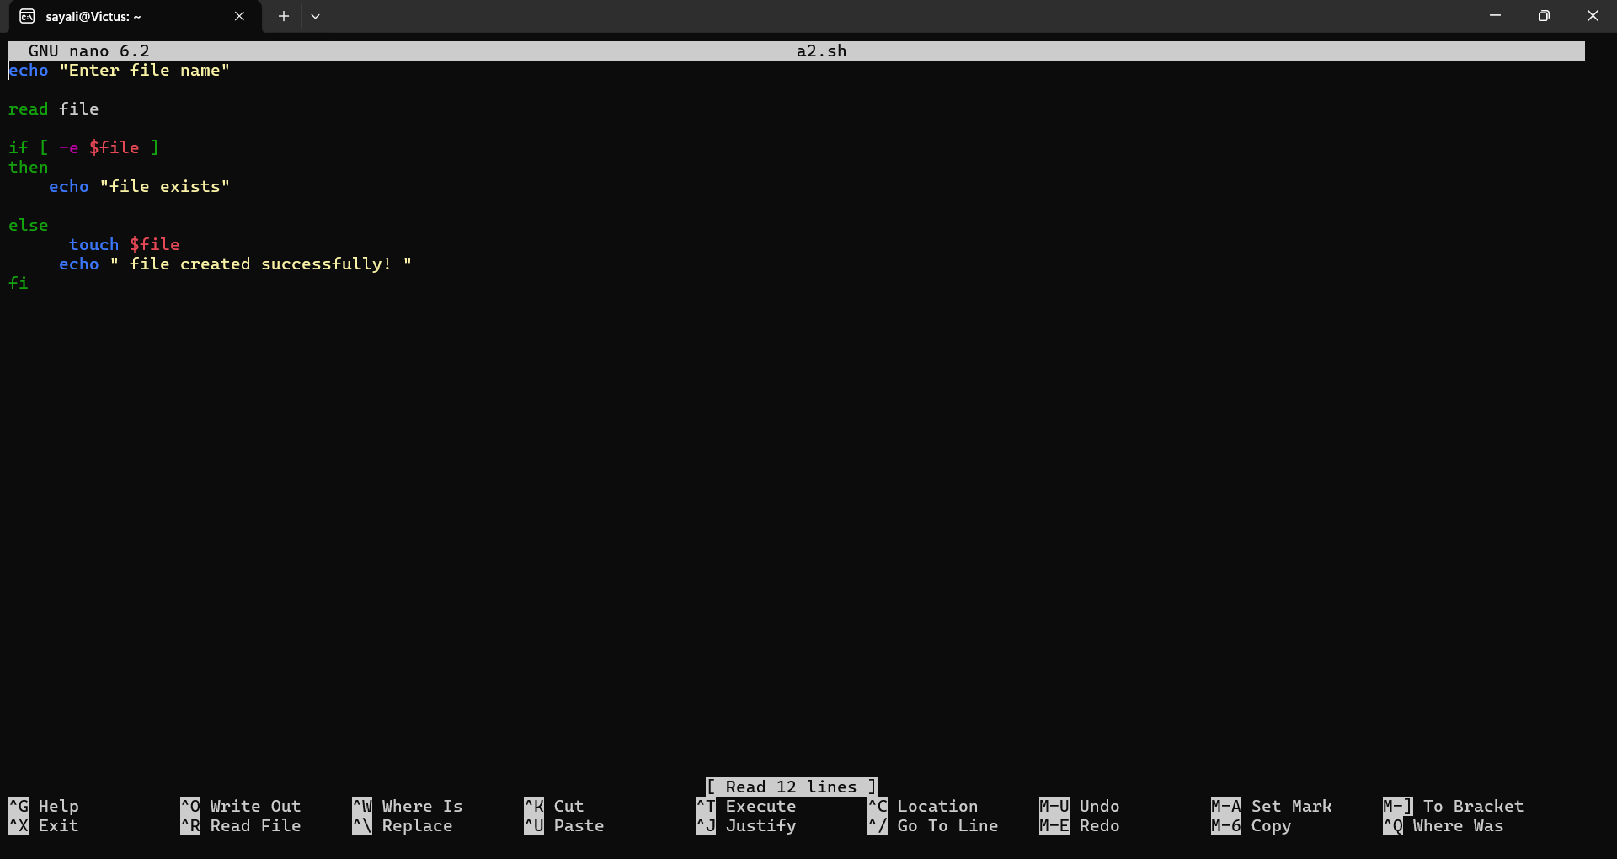

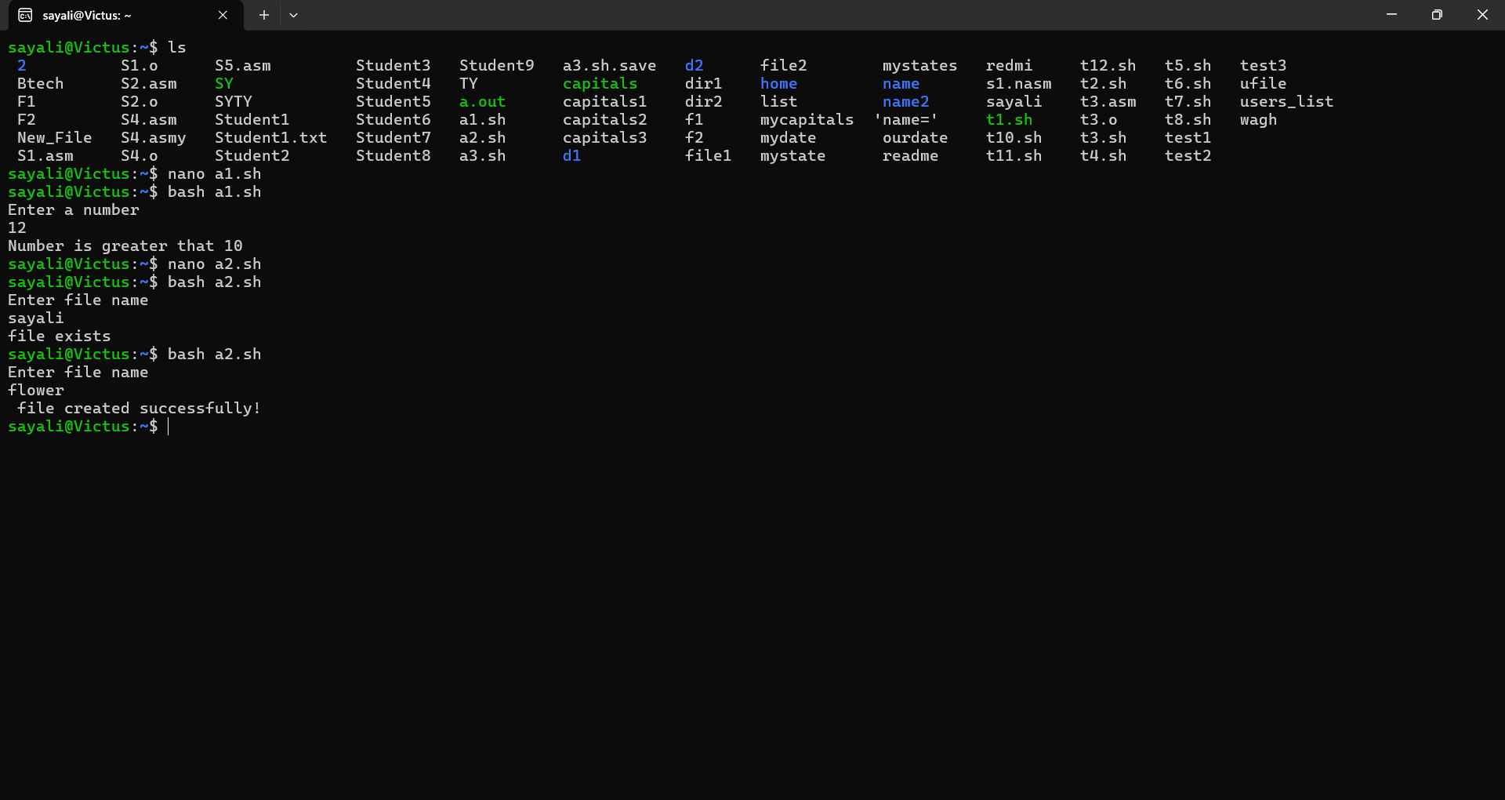

3)Write a shell script that takes two command line arguments. Check whether the name passed as first argument is of a directory or not.

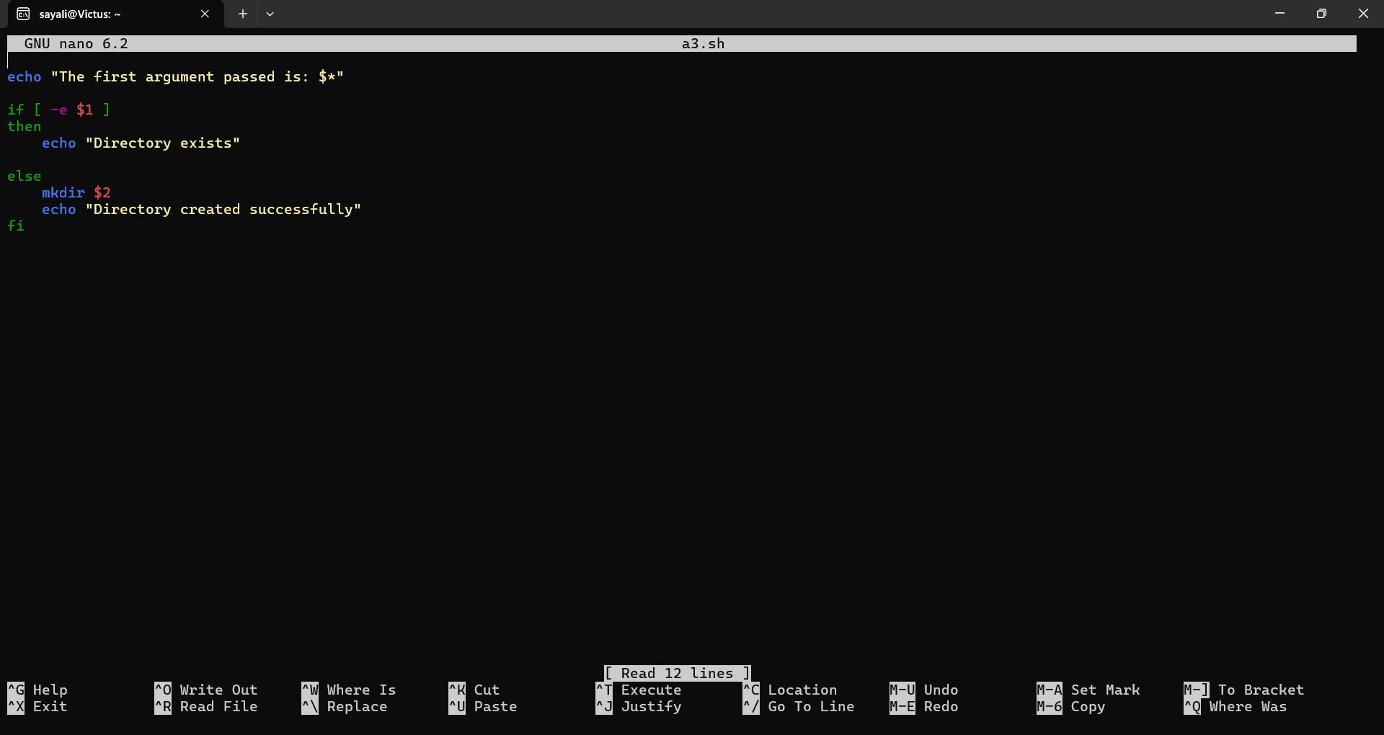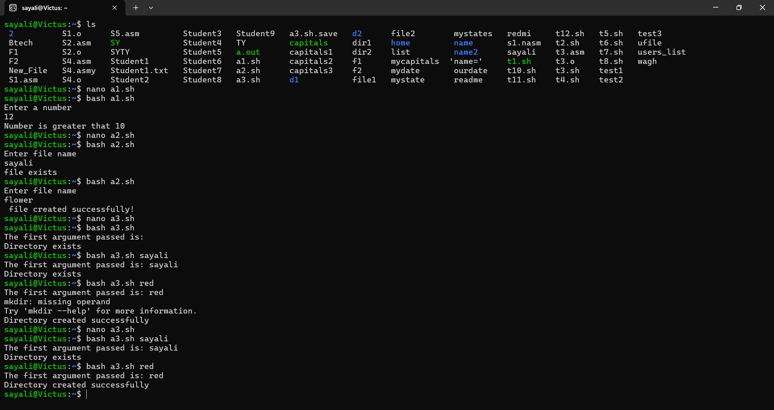

4) Write a shell script which checks the total arguments passed. If the argument count is greater than 5, then display message “Too many arguments” 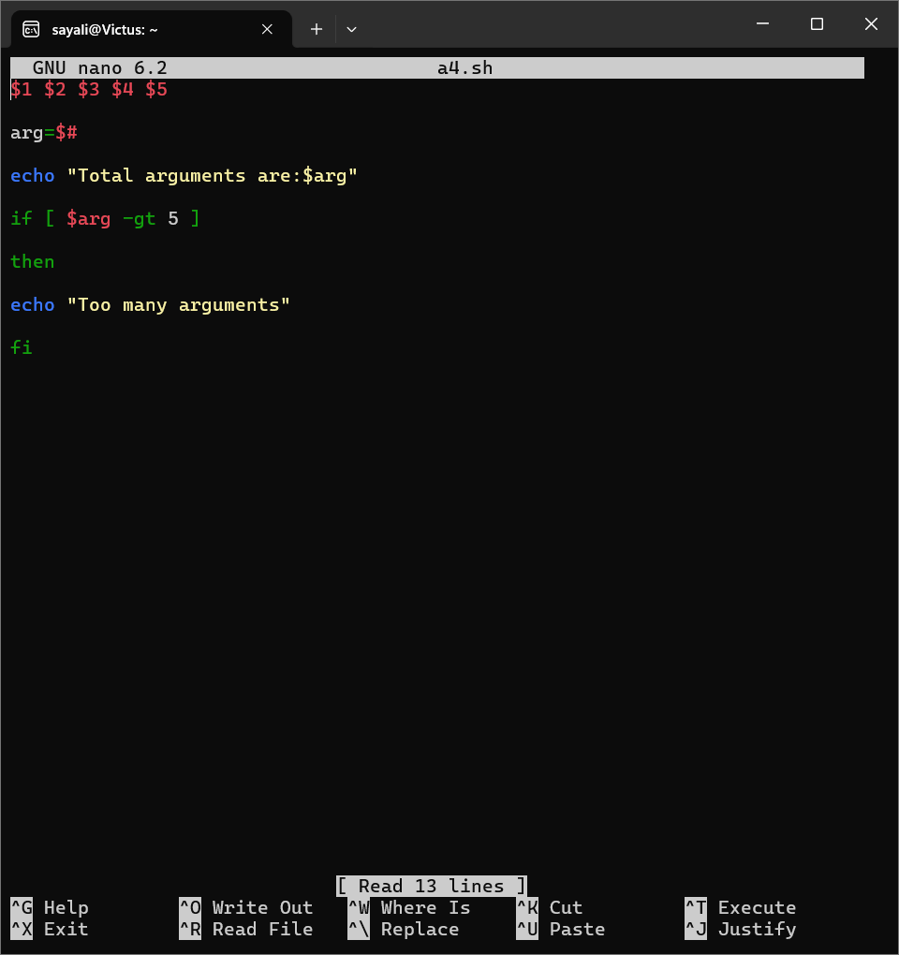

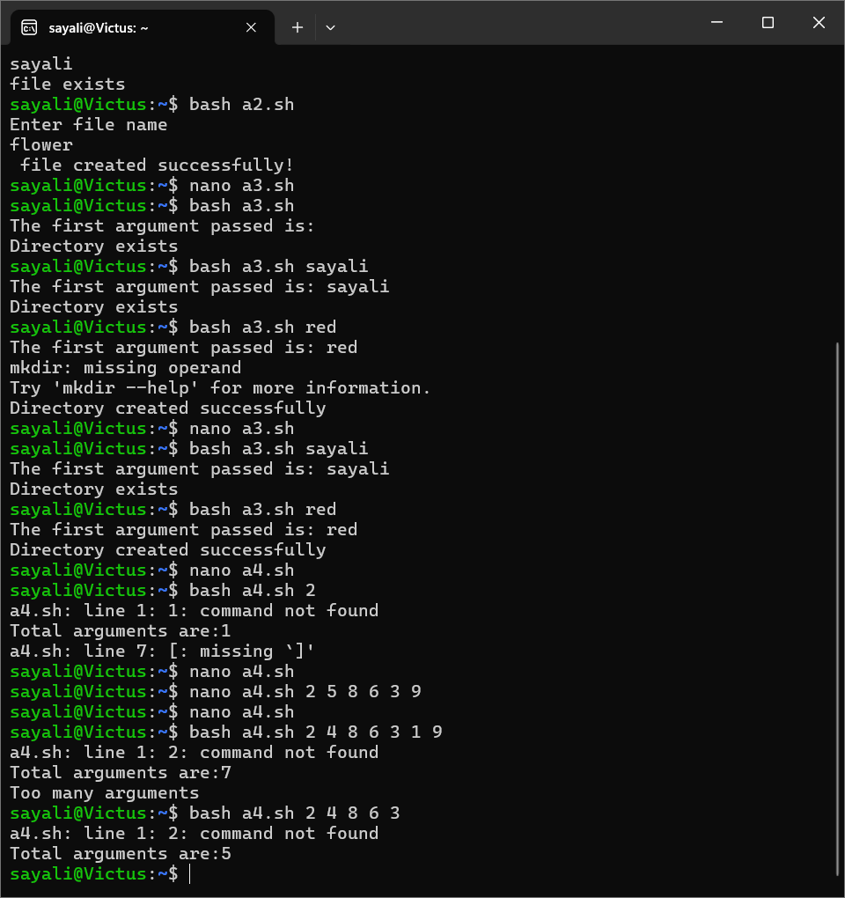

5) Write a shell script to check arguments passed at command line is whether of a file or directory. 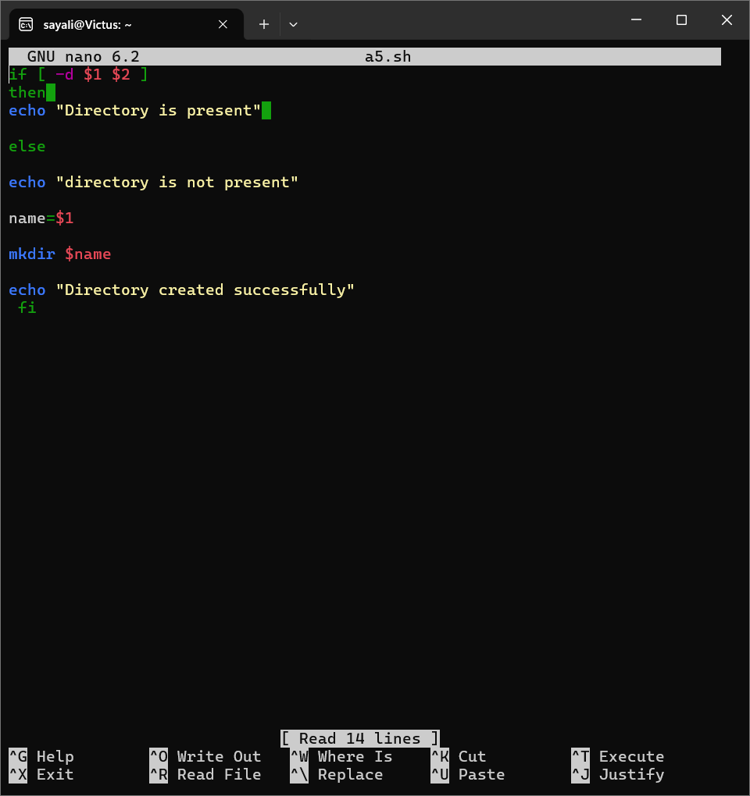

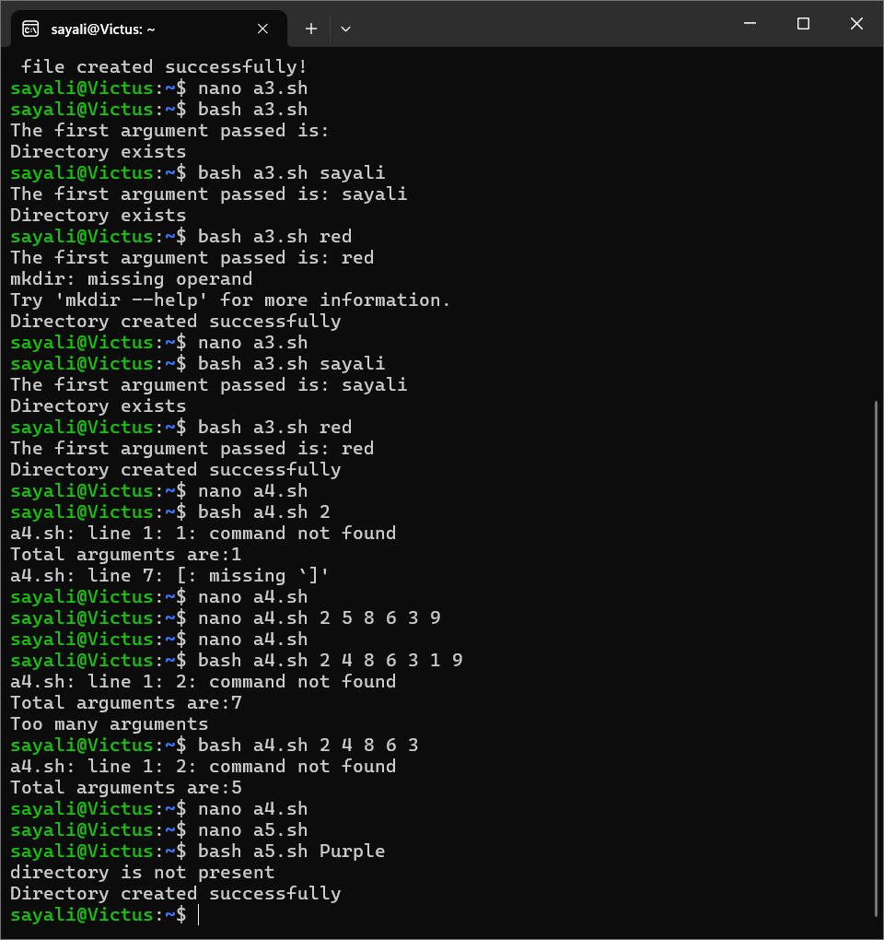

6) Write a shell script to read a month name from the user. Check if the name entered is either August or October.

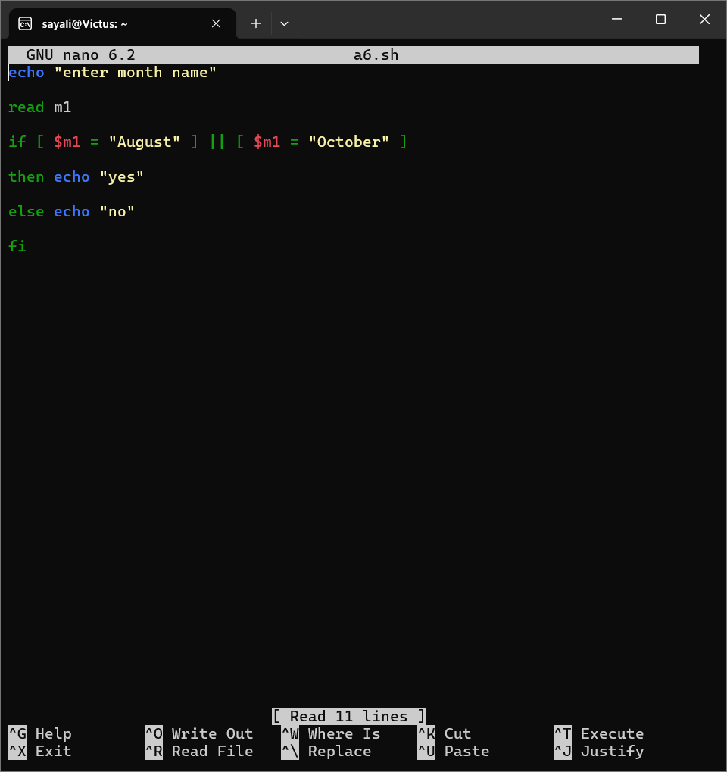

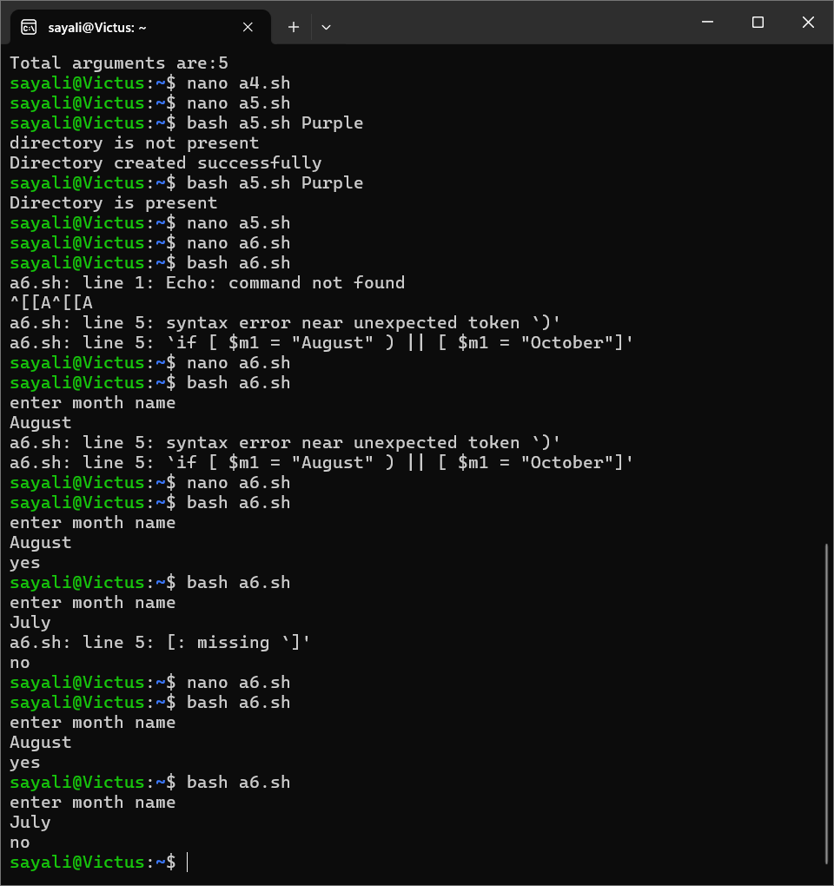

7)Write a shell script to check whether file or directory exists. Write a shell script to check whether file is exists and file is readable.

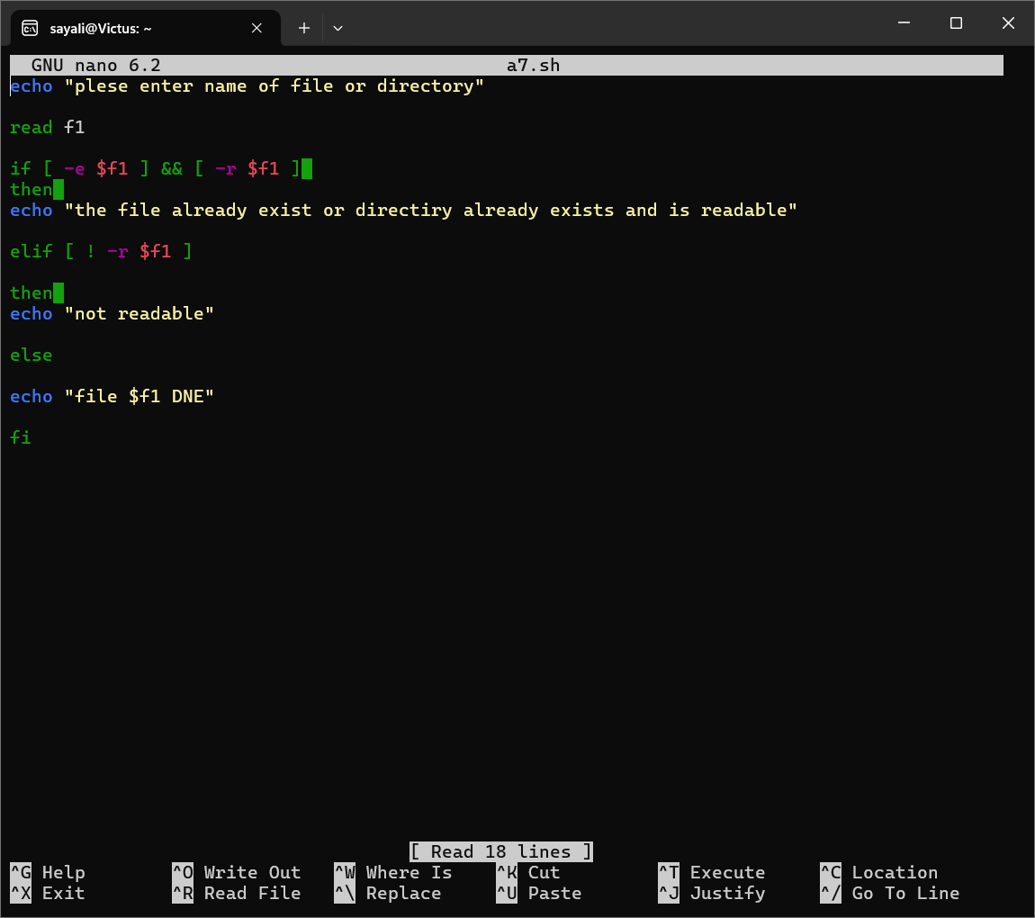

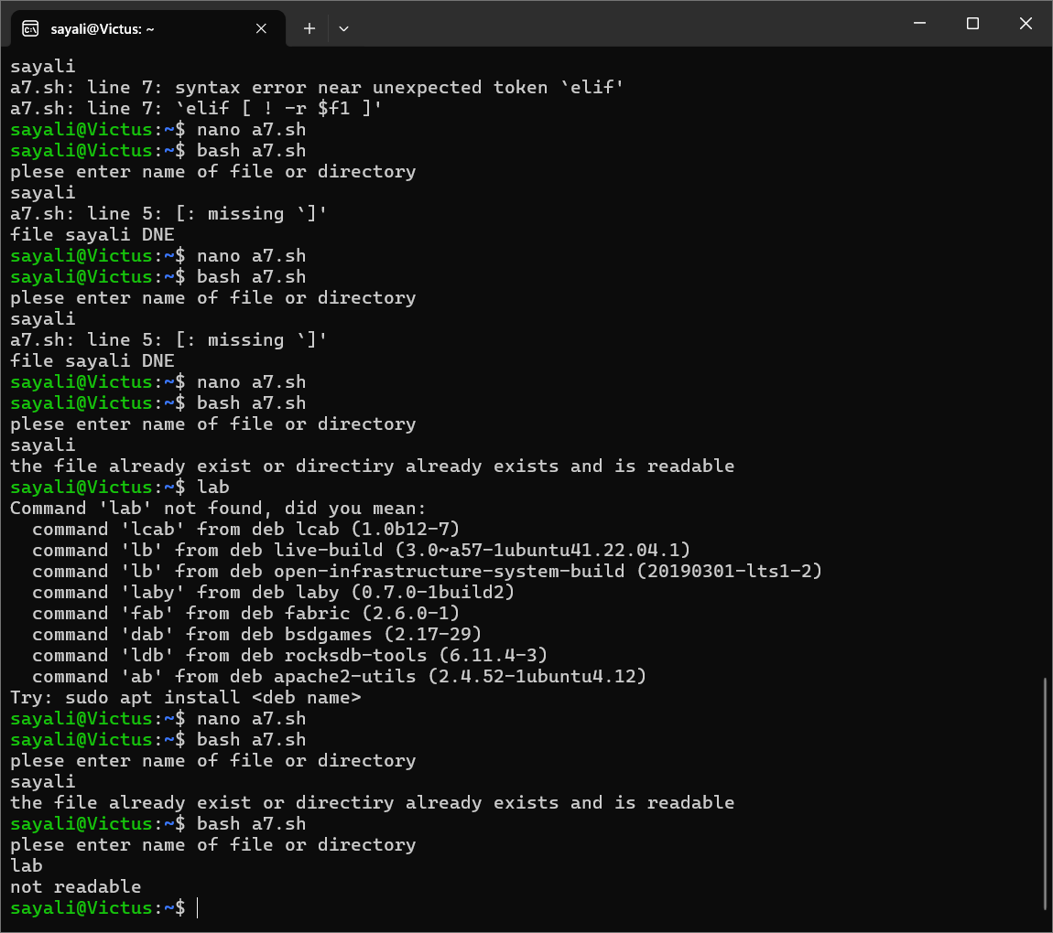

8) Write a shell script to check if the present month is August or not. Use date command to get present month.

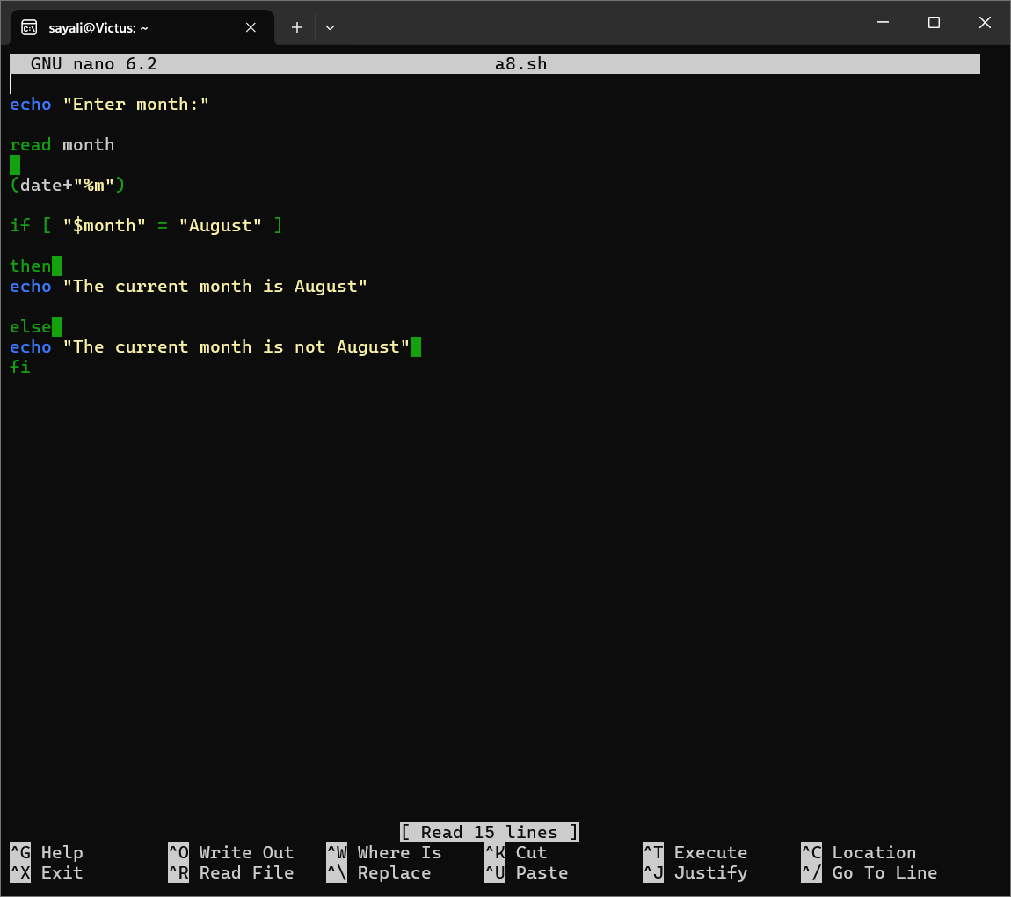

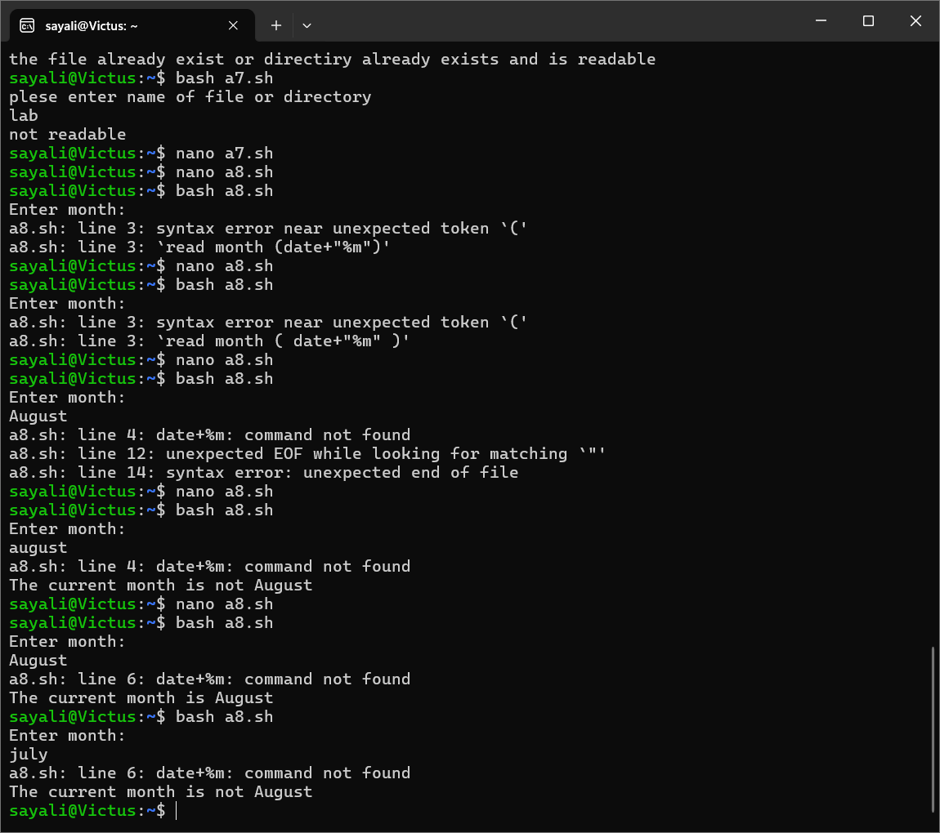

1. Write a shell script to check if the current user is root or regular user.

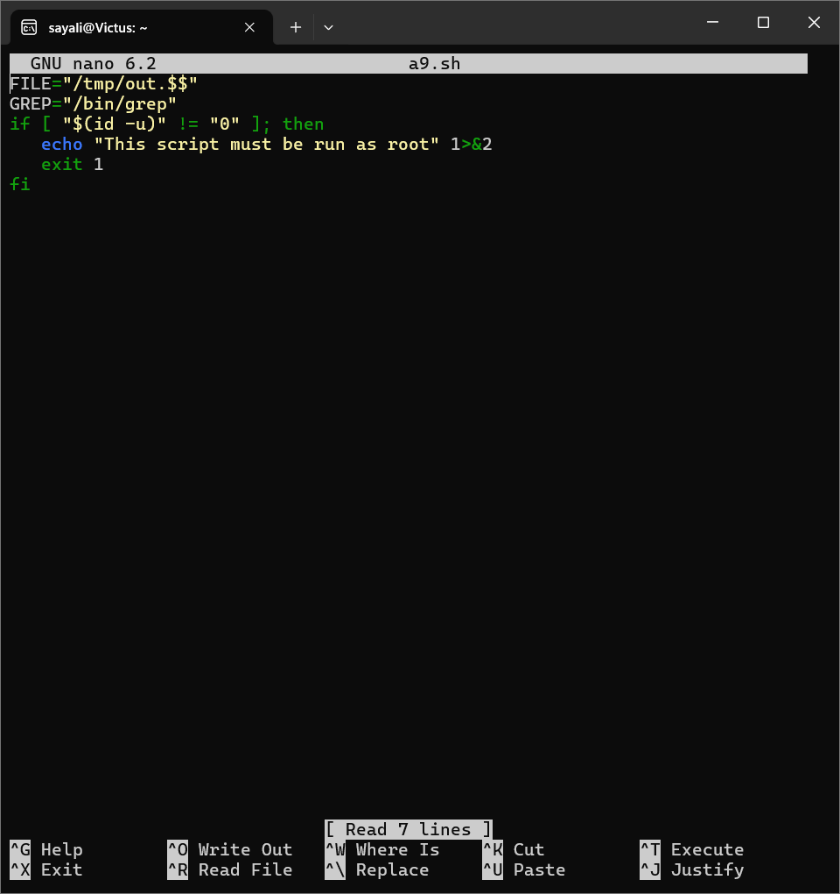

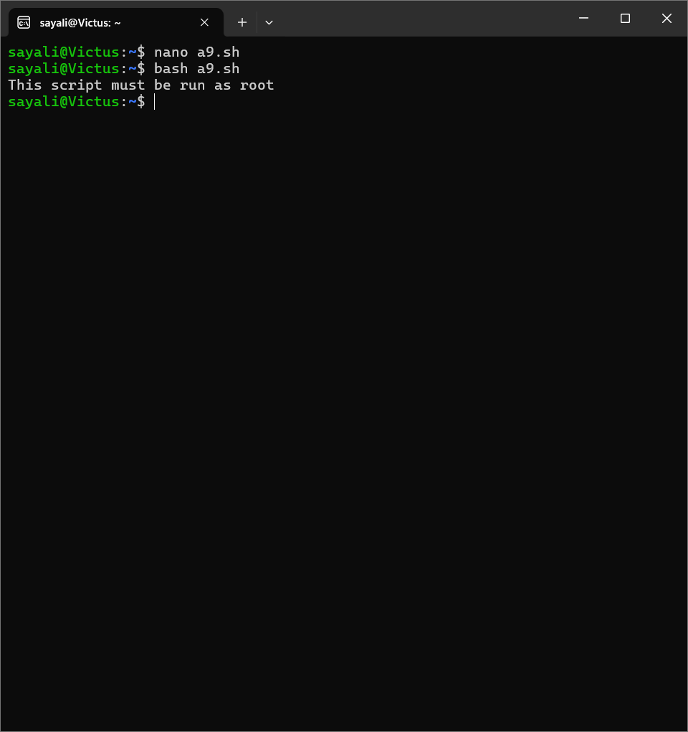

10) Write a shell script to check the total arguments passed at command line. the arguments are more than 3 then list the argument else print “type more next time”

